Weave Advisory Board 1st DRAFT

Notes of meeting of 19th December 2012

Present: Max Comfort, Richard Keating, Val Kirby, Neville Nelder, Stella Parkes, Ben Spencer

Apologies: Kevin Cranston, Carole Garfield, Clare Mahdiyone , Hugh Barton, Ian

I Resumė of inaugural meeting

Given the initial impetus of the Weave Symposium, the University of West of England exhibition and the Academy of Urbanism (AoU) visit, the meeting provided an opportunity to focus on its main aims.
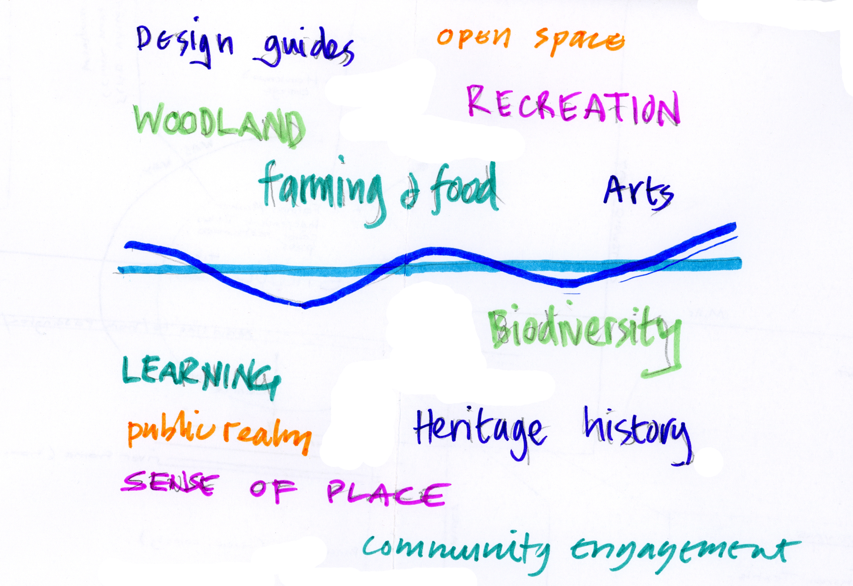
Diagram 1. Initial themes for the Weave to champion

The meeting agreed that the Weaves primary focus is to engage people with community planning processes as it relates to the Cotswold Canals and River Frome Corridor between Sapperton and The River Severn.

ACTION: This to be revisited as part of writing a constitution for the Weave

2 AoU Report and Implications for The Weave

Agreed that:
- the AoU visit had been useful and generally well received – had so far raised the Weave's credibility
- The Weave would provide the feedback to the AoU in a constructive way which recognised the pilot status of Stroud in the “Place Partnering” programme
- feedback to suggest restructuring the report to include an executive summary sheet of recommendations, details put in appendices and to include context setting, especially regards the degree to which the brief was met
- in a number of the comments about the report that had been received, some disappointment was raised particularly regards the risk of reopening differences between the sectors and lack of adventurousness
- the meeting felt it necessary to arrange a feedback session to those who had attended the AoU sessions – to use it as an opportunity to agree local priorities and direction (see below). AoU to be invited and given the choice of either observing or facilitating the discussions

ACTION: Max to contact AoU

3 Neighbourhood Planning and potential role for The Weave

Stroud Town Council are anticipating preparing a Neighbourhood Development Plan and recognise the resources available in the local community regards planning, Green Infrastruture, facilitation and community engagement, sustainable communities and Public Relations. The Council may decide to go down the route of working with a group of local experts. No decision has been taken yet on the geographical boundary to be chosen which might or might not include other Parishes.

It was agreed that The Weave should approach the Town Council to suggest a collaborative event to feed back on the AoU report and scope the potential for collaborating regards Neighbourhood Development Planning.

ACTION: Richard to prepare a draft meeting agenda/programme aimed at The Weave and Town Council based on the following framework:
- Finding common Ground over the AoU Report
- What to do next
- Who to do What
- Neighbourhood Development Plan
- Resources
- practical workshops aimed at mapping groups, inviting others in

4 Other Weave Plans and Resources

- Val is talking with the Canal Team with the suggestion of helping with the consultation aspects of phase 1b
- Val has been exploring an HLF bid, “Canal Connections”, for getting some “intelligent admin. Support”. This would need to include Heritage project delivery so need to talk with Stroud Valleys Project, Canals Trust, Museum and people with an interest in signage
- Richard is continuing to walk and draw with groups to engage them with the earlier work of The Weave, in particular developing a Green Infrastructure Framework for phase 1a area and promoting links with the Museum.
- Also with Walking The Land, doing work with the University of Gloucestershire on flooded landscapes and Community Resilience
- The meeting agreed that a way of attracting and managing resources would be to establish a not for profit company or similar. All present to consider being directors.

ACTIONS:

- Val to develop Canal Connections bid
- Richard to continue community engagement art walks
- Max to approach Stroud Common Wealth regards Thew Weave setting up as an independent body

